Index
- Log in.....................................................................3
- Home.....................................................................4
- Devices..................................................................5
  - Device Search
  - Point of interest
  - Group Management
  - Create Fence
- Tracking................................................................7
  - Playback Tracking
  - Live Tracking
  - Detailed History
- Alert.....................................................................9
  - Maintenance
  - Speed Limit
  - Schedule Alert
  - POI Alert
  - Digital input Alert
  - Fence Alert
  - Over Stay Alert

- Reports................................................................11
6.1. Fleet summary report
6.2. History Report
6.3. Latest Location Report
6.4. Speed monitor report
6.5. Poi report
6.6. input history report
6.7. stoppage report
6.8. Travel distance by latlang
6.9. Trip distance report
- Setting.................................................................15
  - Alerts Log
  - My Profile
  - Change Password
  - Download Kml

- Log in :

- This is log in screen. User can log in this website with valid username and password which is provided By bonrix software system admin.

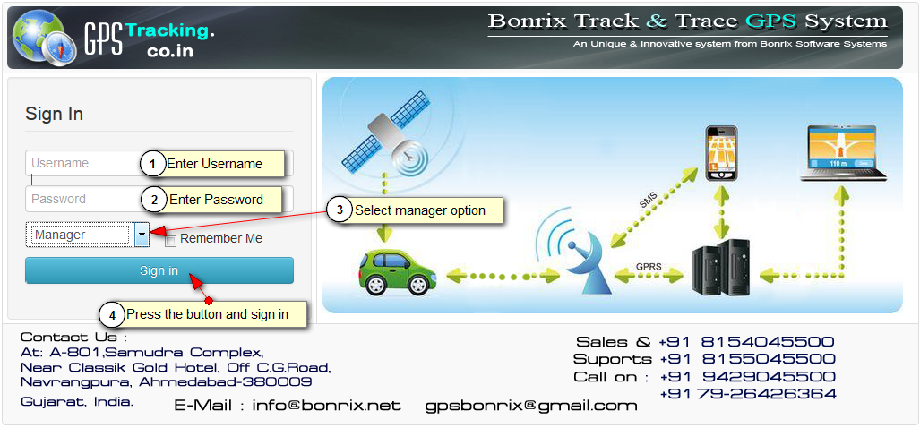

- Home :
- In this Home Page, Live View of Vehicles is shown. You can see speed, hold time, status, latitude and longitude of vehicle.
- In the left side of Screenshot you can all the information for vehicle like vehicle no, driver mobile no and all the vehicle of customers to be tracked.
- On the Right side, you can see all the parameter of vehicle like Ignition, Charging and power of vehicle. In the bottom of right side you can see dashboard of your vehicle like speedometer and odometer.
- In the middle, Red signal of car indicate off state of vehicle, green signal of car indicate on state of vehicle and black signal indicate disconnection of vehicle from server.
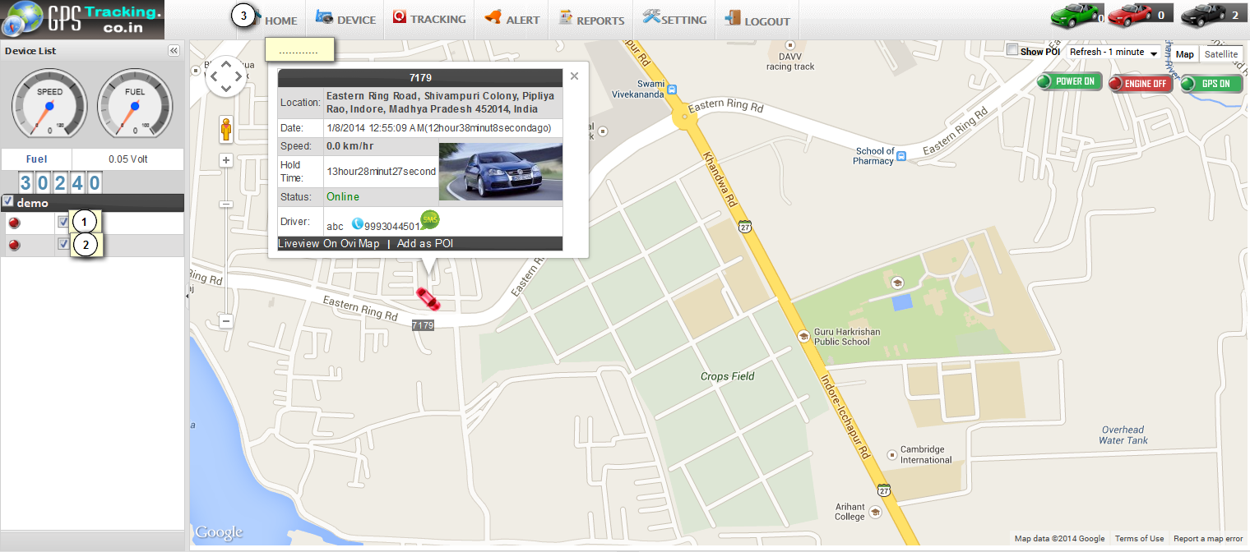

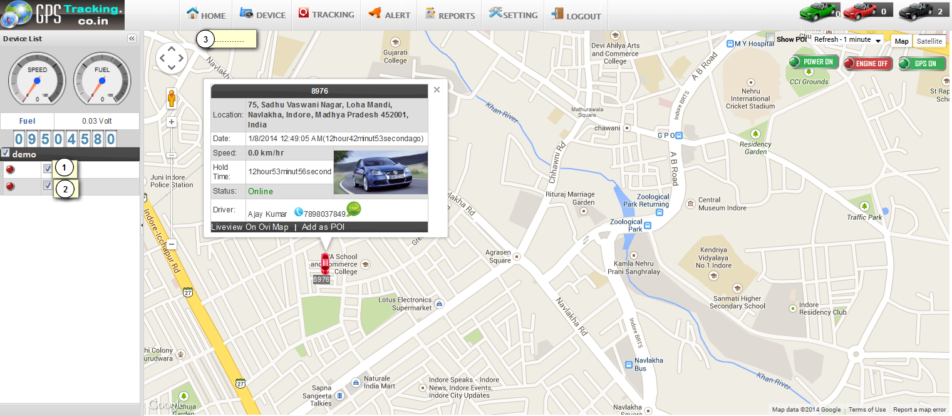

- Devices :
  - Device Search :
- Here you can manage all the functionalities of GPS devices which are placed on your vehicle.
- Functionalities of Devices manage are as under.
- you can manage all the information like add, edit, delete of particular devices and vehicle.
- Following Snapshot gives Device Search info:
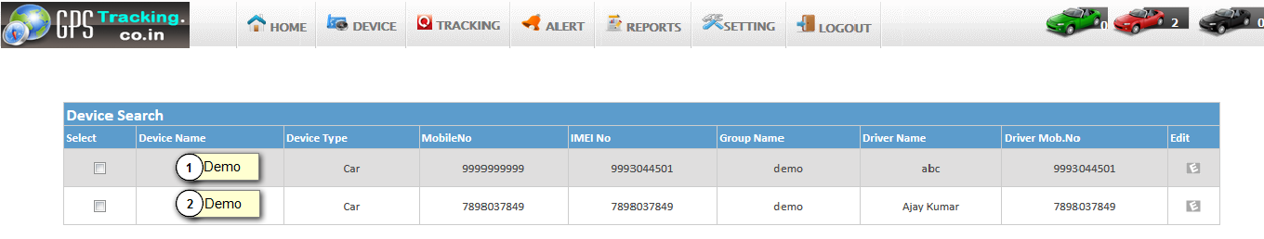

  - Point of interest :

- Here you can set your point where you want to locate your vehicle.

- Following Screenshot give Point of Interest Information.

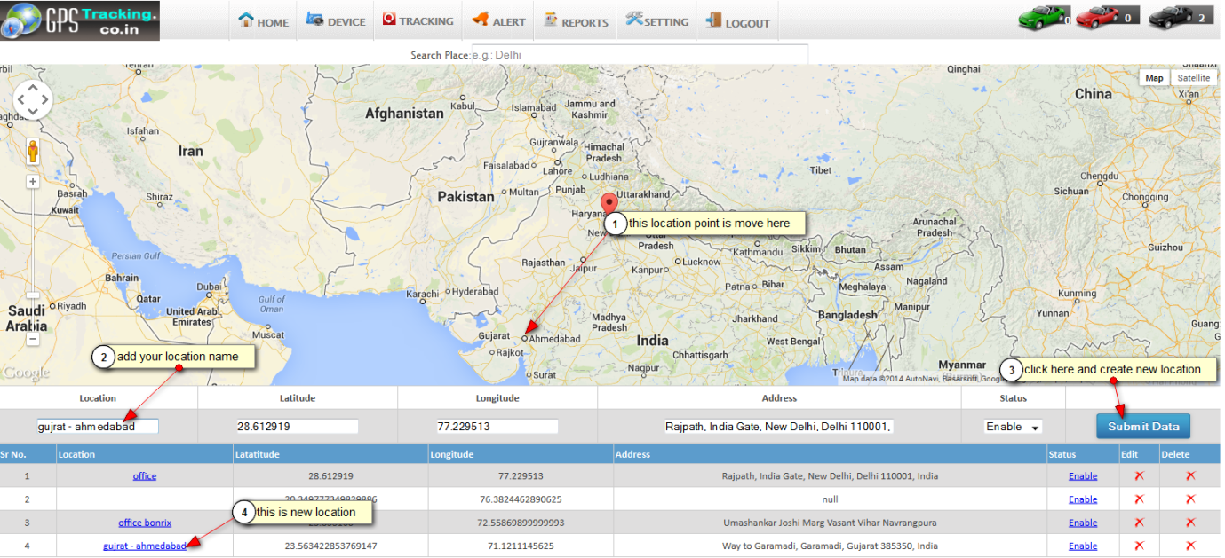

  - Group Management :

- Here you can manage group add , edit, and delete functionalities.
- Following is the Screenshot of Group Management:

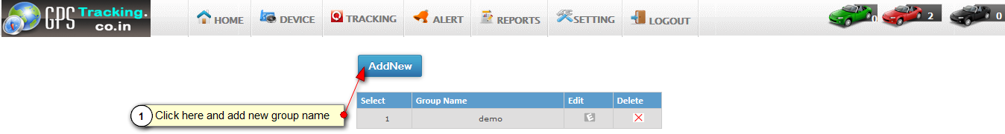

  - Create Fence :
- Here you can arrange the fence like polygon, square, circle etc.
- Here you can find square on Google map giving starting and ending positions.
- Following is the Screenshots of Locate Polygon, square:

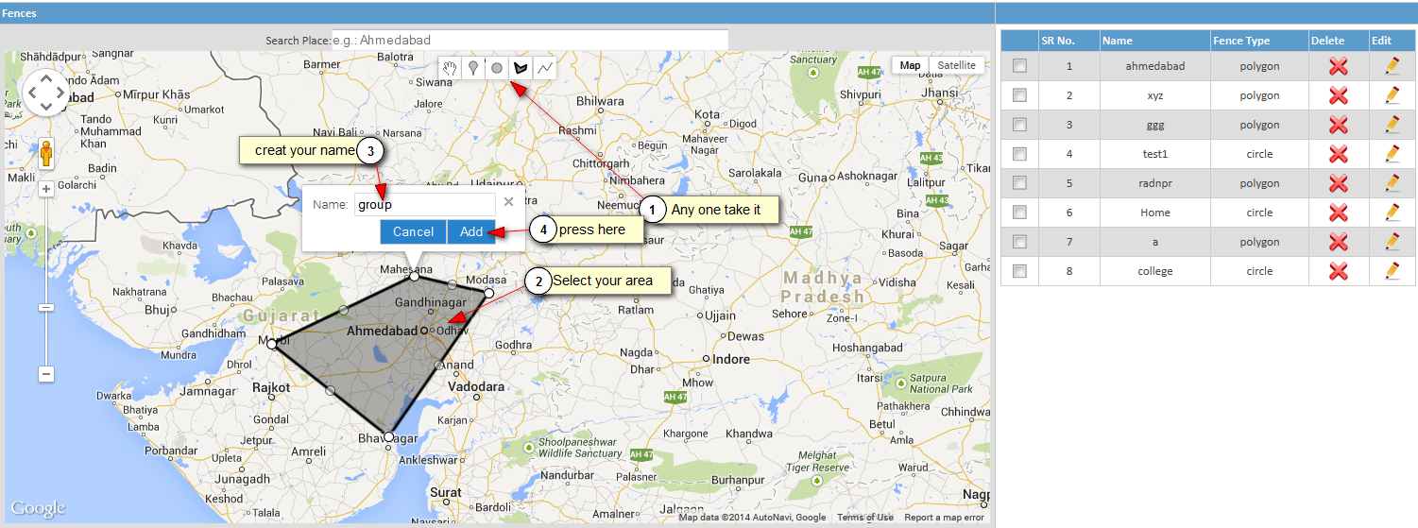

- Now, you can See in right side table your fence location is create.
- Following is the Screenshots of create new fence in table:

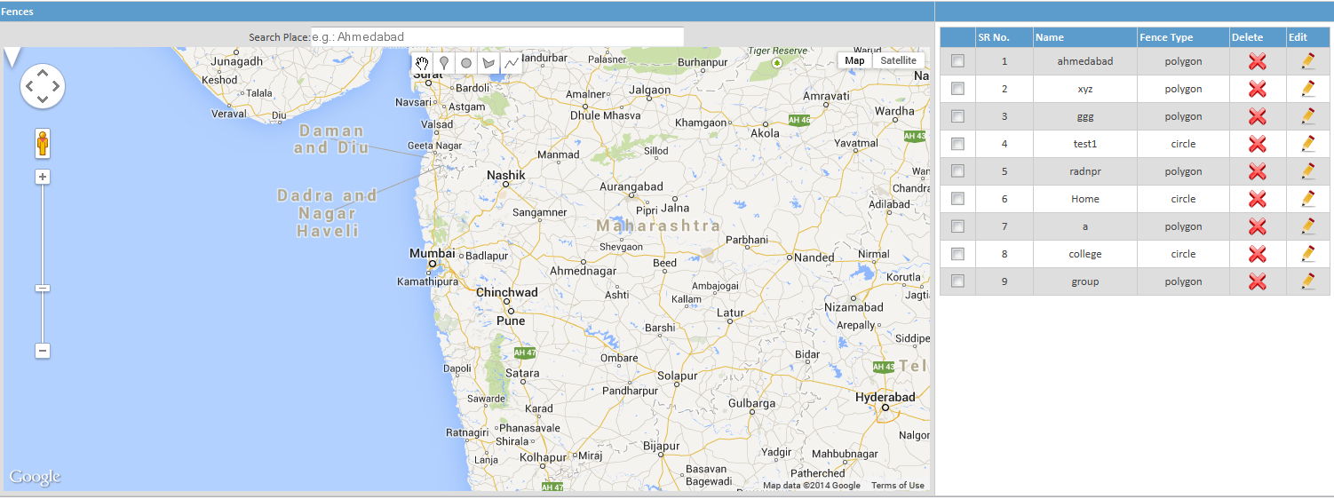
- Tracking :
  - Playback Tracking :
- Here you can track all the past path of your driving vehicle.
- Following is Screenshot of Playback Tracking:

- In following figure you can see that all the path of vehicle last track is given using red and green line.
- We should give a proper input for generating last track.
- In the figure you can see the path of vehicle past track using start date and end date and time.
- Here Green line indicates moving position of your vehicle and red line indicates your vehicle stoppage

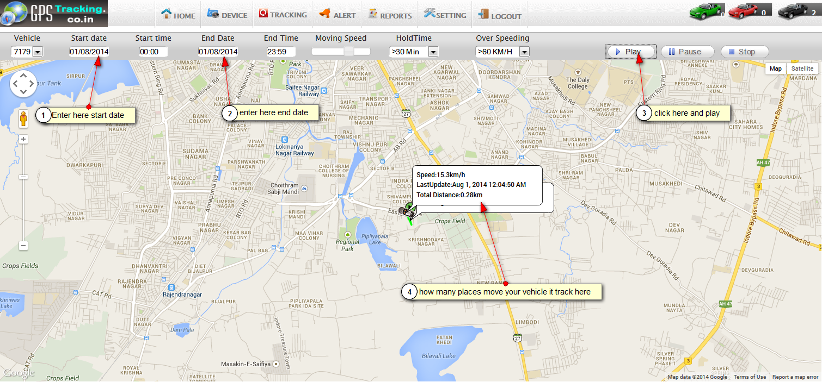

  - Live Tracking :
- Here you can take live tracking of your vehicle.
- It will give current position , speed, and ignition status of your vehicle.
- Following is Screenshot of live Tracking.
- Here you see the current position of Vehicle.
- In the upper part you can see status and speed of your vehicle.
- In the bottom part you can set your refresh time of tracking.

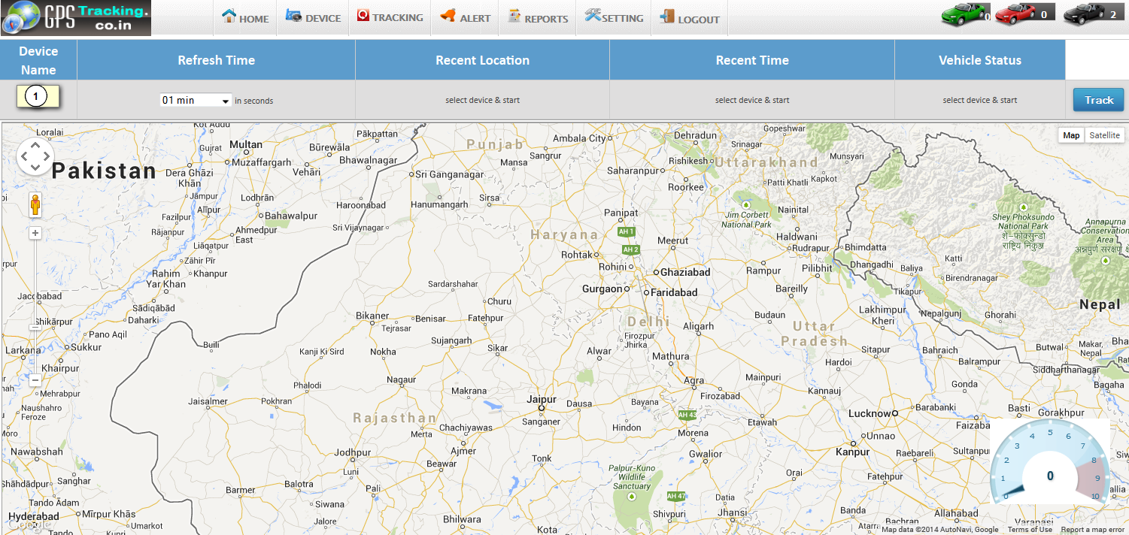
  - Detailed History:

- Here you can find all the History data by date and time.
- Here you can find all the stoppage of Vehicles.
- Following Screenshot gives Stoppage Information:
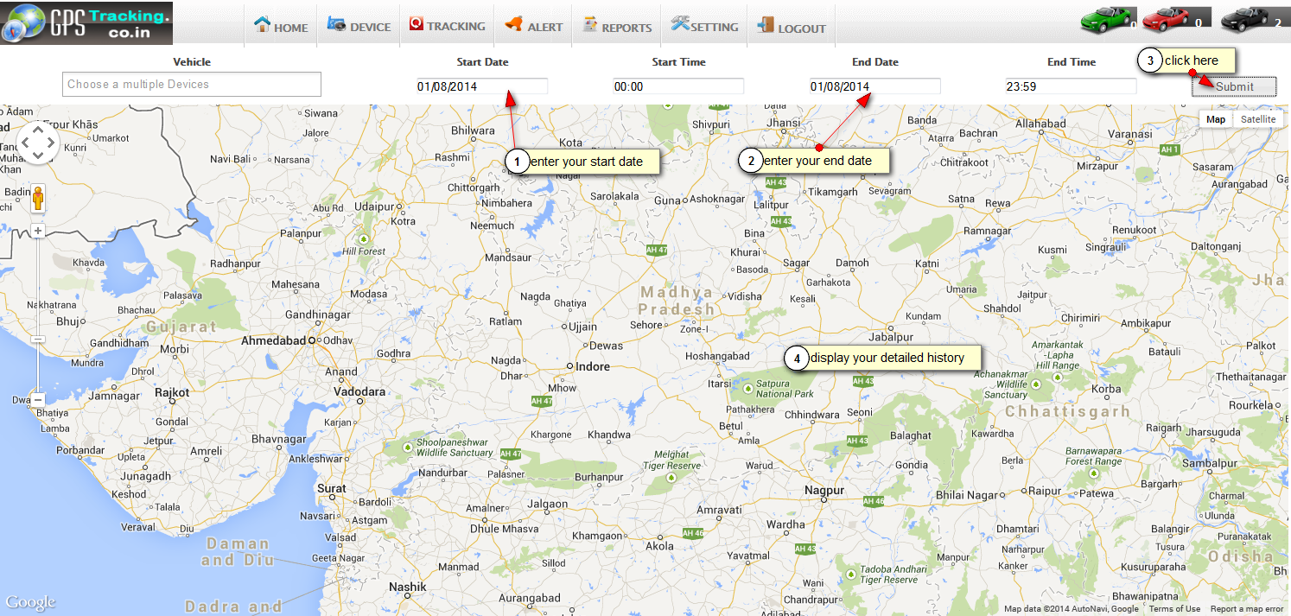

- Alert :
  - Maintenance Alert :
- Using maintenance alert client can set reminder for different alerts .
- Like service reminder, insurance reminder, oil change date reminder, etc.
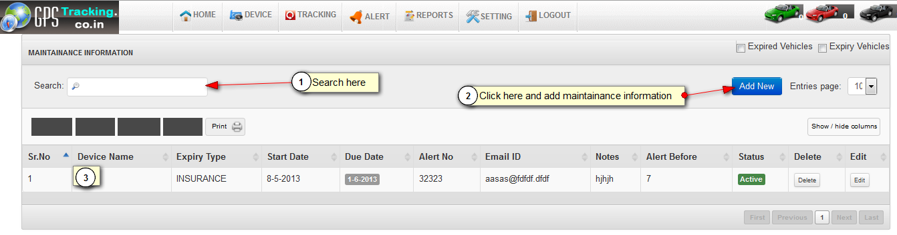
  - Max Speed Alert :
- Here you can send Max speed of vehicle alert history to the customer.
- Following Screenshot of Max Speed alert and it history:

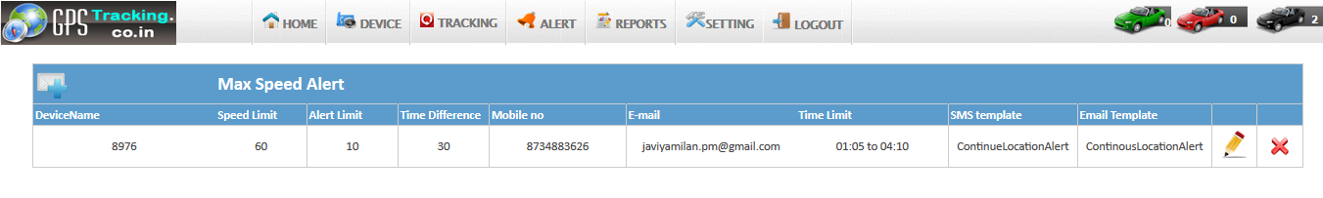
  - Schedule Alert :
- Using schedule alert client can set scheduling for different purposes.
- Like seat location every day in particular time, etc.
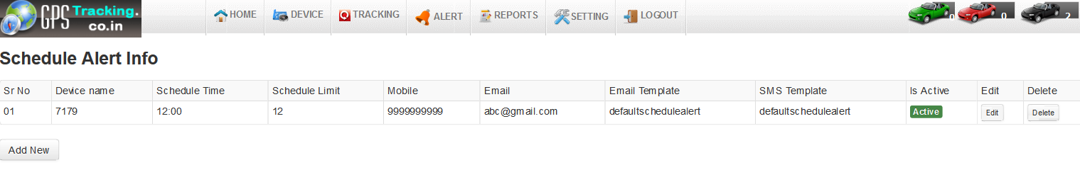
  - POI Alert :
- From Here you can send your selected POI alert sms to the vehicle device.
- Here you can send POI Alert History to the vehicle Devices.

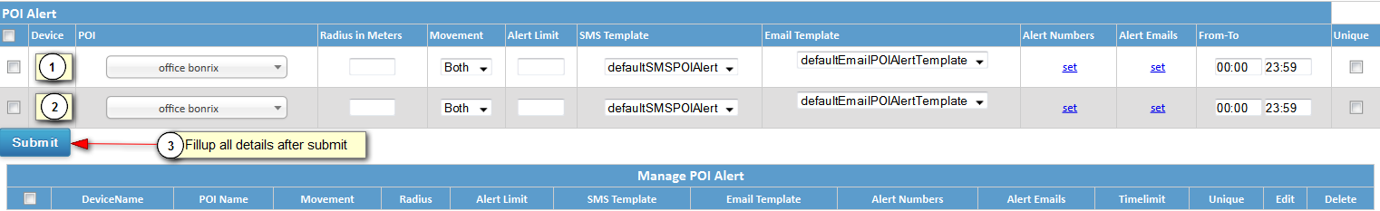
  - Digital input Alert :
- Here we can send digital Information for location points to customer.
- Here you can send Digital input history information to the vehicle devices.

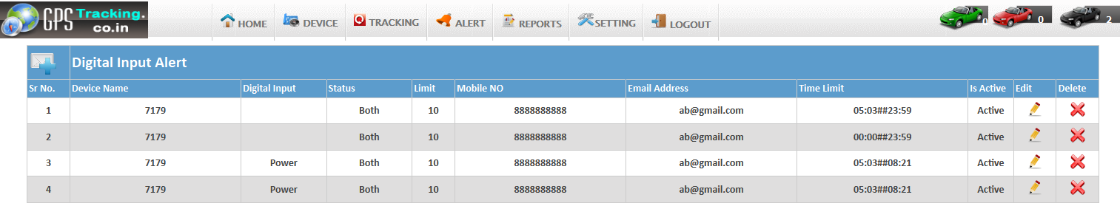

  - Fence Alert :
- Her we can send Fence Information to Customer.
- Here you can send fence Alert History to the vehicle devices.

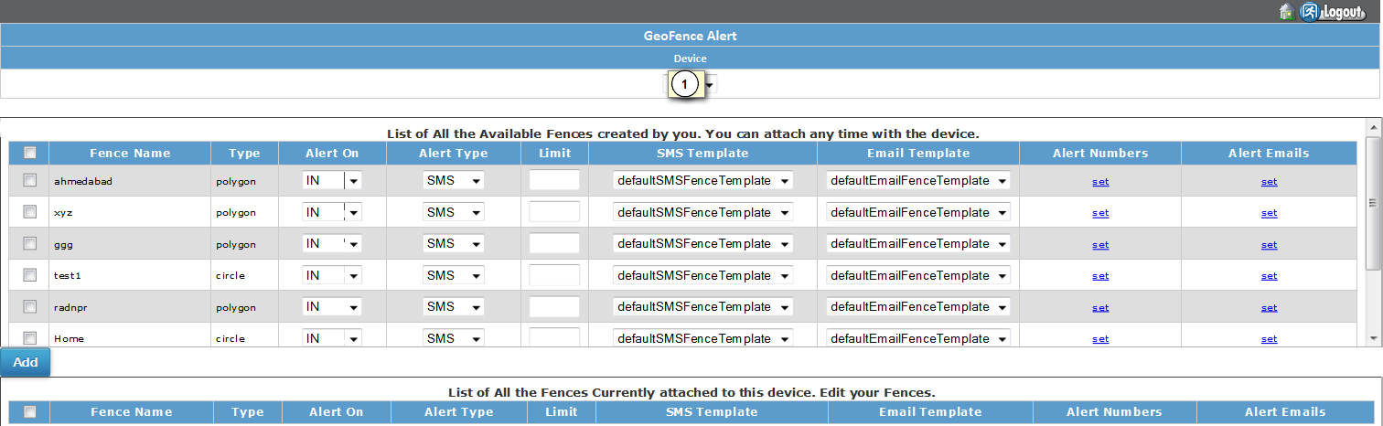

  - Over Stay Alert :
- It will generate when vehicle over stay greater than defined over stay time.
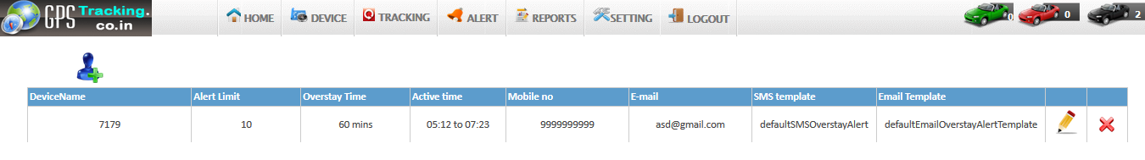

- Reports :
- Here you can generate reports of vehicle information like vehicle location, path, max speed, ignition etc.
- Following is the Screenshot of Report management:

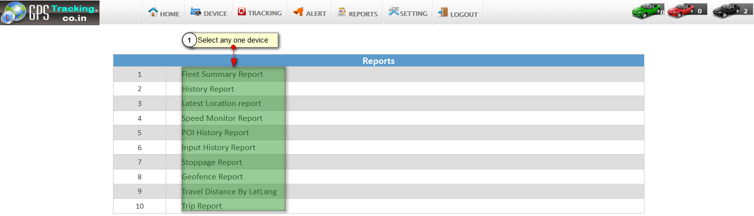
  - Fleet Summary Report :
- Here you can generate current day information to device based on given time .
- Following is Screenshot of Fleet summary report.
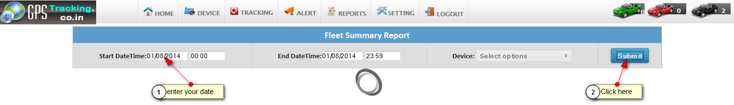
  - History Report :
- Here you can generate history of device parameters in reports.

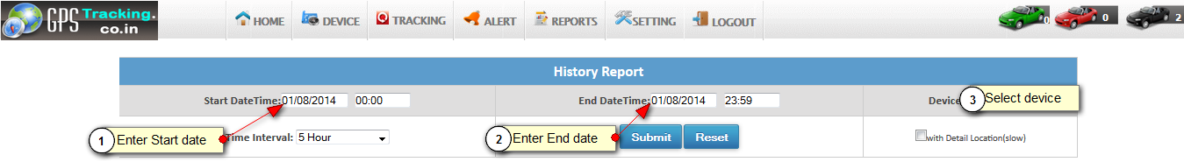

- Here you can see your history report.

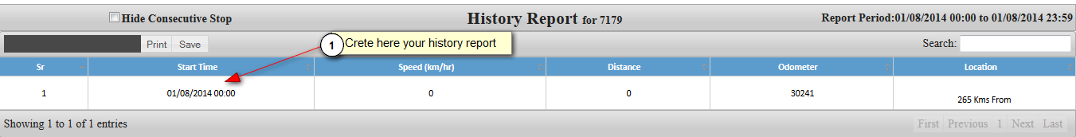

  - Latest location report :

- Here you can generate reports of last tracking of vehicle device.
- Following is the Screenshot of Last Track report:
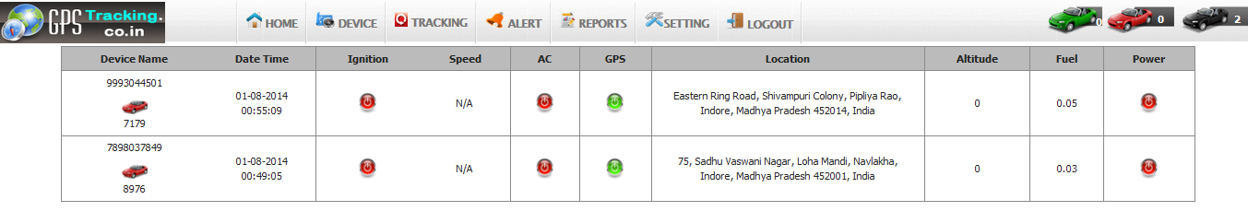
  - Speed monitor report :
- Here you can generate all speed information’s reports of vehicle last track.
- Following is the snapshot of Speed Monitor Report.
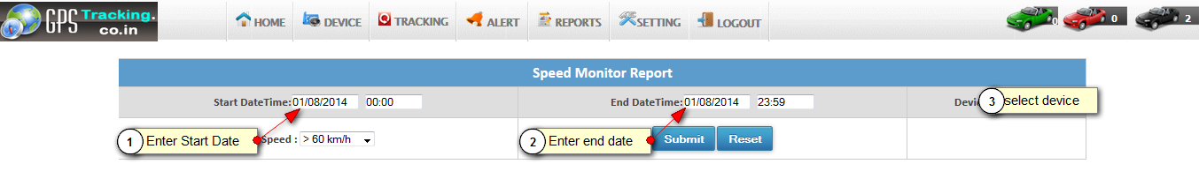
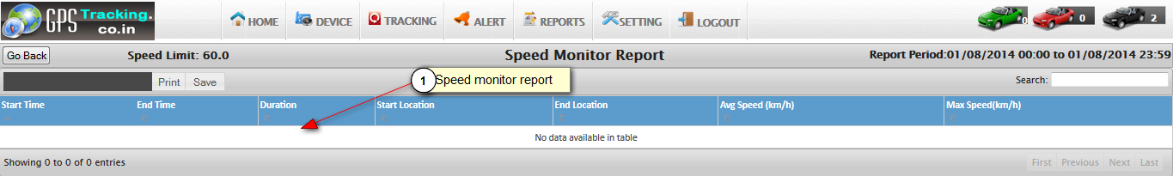
  - POI Report :
- Here you can generate all POI In formation information report.

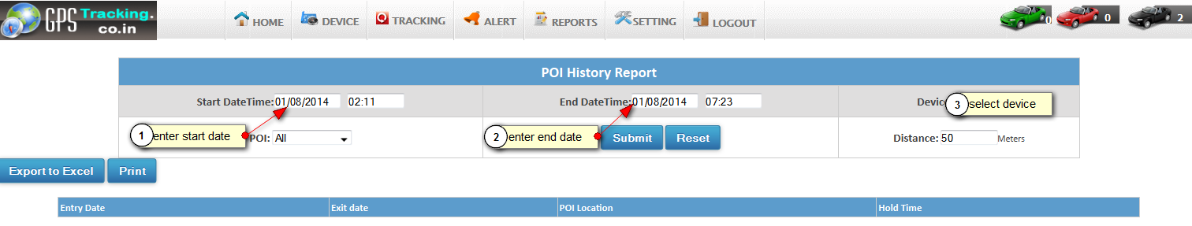

  - Input history report :

- Here you generate on and off time of vehicle information report.
- Following is the Screenshot of Input History Report:

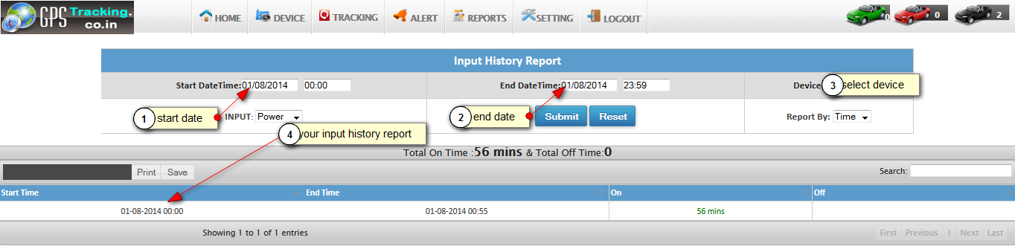
  - Stoppage Report :

- Here you can generate all the stoppage information of your vehicle at specified time.
- Following is the Screenshot of Stoppage report:
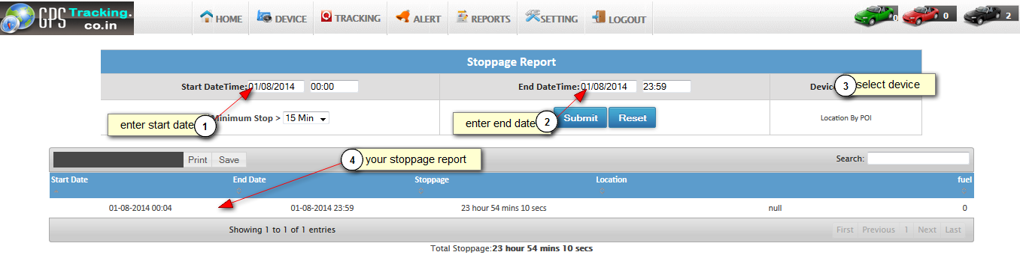
  - Distance travel report :

- Here you can generate report about the total distance travelled and total fuel consumed.
- Following is the travelled Distance report:

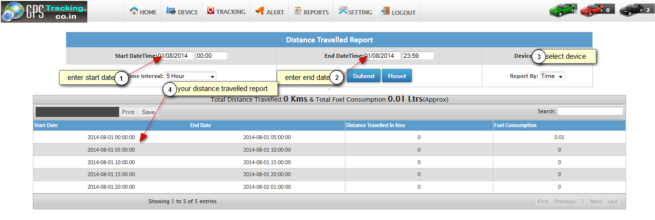

  - Trip report :

- Here you can generate trip report of vehicle which is defined on specified time interval.

- Following is the Screenshot of Trip Report:

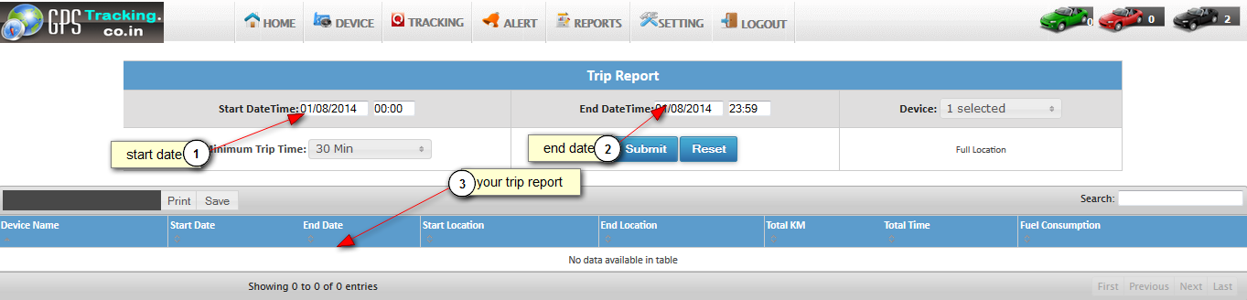

- Setting :

  - Alert Log :

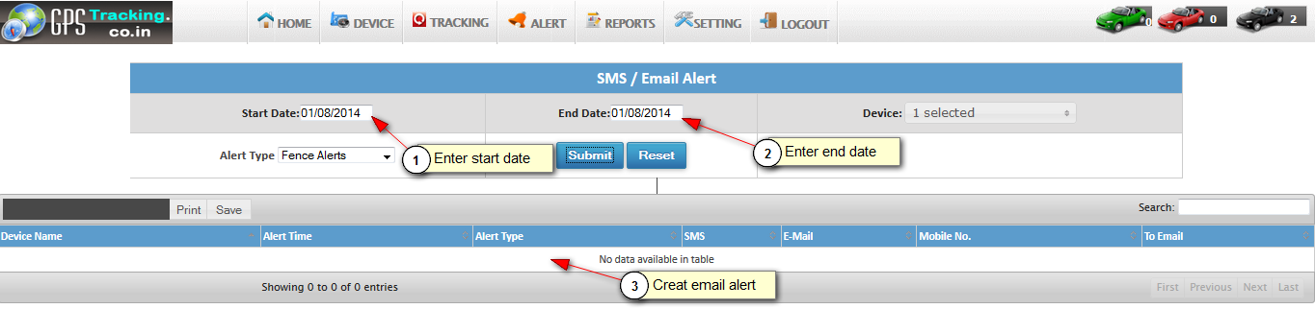

  - My Profile :
- Here you can manage your personal profile for every user.

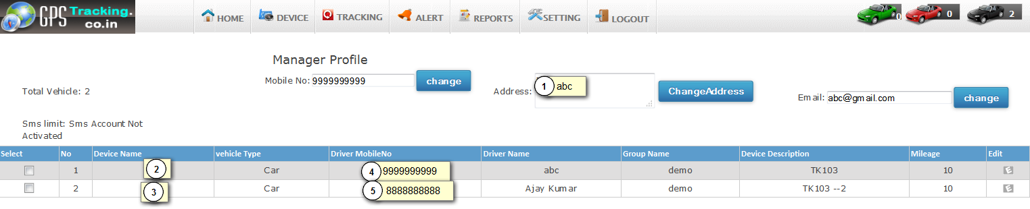

  - Change Password :

- Here you can change your user password .

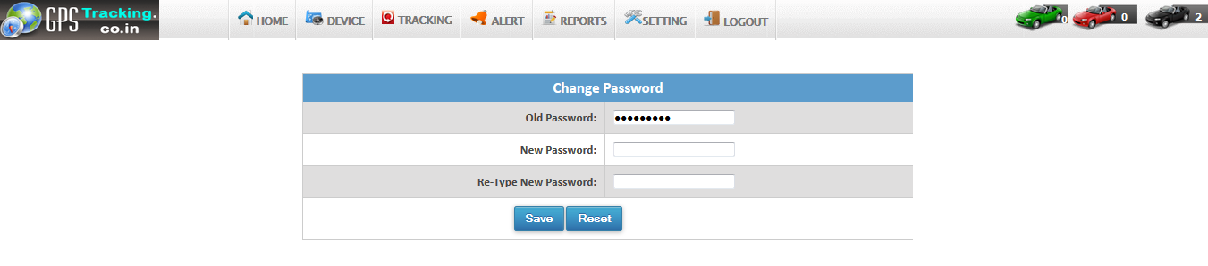

  - Download KML :

- Here you can download KML file of device location .
- using this file you can see all the routes track of your vehicle in Google earth.

